Southern Regional Healthcare Executive Committee Minutes
Southern Regional Healthcare Executive Committee Minutes

April 20, 2021
2021
Southern Regional Healthcare Coalition Executive Committee Meeting
April 20, 2021 via Zoom Meeting 0930-1100

Documents and materials provided for the meeting
April 20, 2021 Meeting Agenda
Powerpoint Presentation
Budget to Date
Southern RHCC HVA
2021-2022 CAT Workplan
2021-2022 Draft Budget
Member Grant Applications
SRHCC Highly Infectious Disease Plan Annex
SRHCC Meeting Minutes, March 23, 2021

Call to Order
Co-Chair Birgen called the meeting to order due to Chair Jen Staton not being able to attend

Roll Call
Members Present:
- Greg Coleman, Park County DES
- Charlie Hanson, MT DES
- Birgen Knoff, Bozeman Health
- Bill Hodges, Big Horn Hospital
- Jason Mahoney, AMR/EMSC
- Kevin O’Loughlin, MT DPHHS
- Scott Rainey, Vitalant
- Don McGiboney, MT DPHHS
- Jacob Brown, MT DPHHS
- Cindee McKee, MHA
- Casey Driscoll, MHA SRHCC
- Kitty Songer, MHA CRHCC
- Kyrsten Brinkley, MHA WRHCC
- Robbie Kavon, MHA ERHCC
Guests Present:
- Paula Small-Plenty, Big Horn Senior Living
Members Not Present:
- Rob Farnum, Pioneer Medical Center
- Stephen Schmid, Life Flight Network
- Jennifer Staton, RiverStone Health
- Sue Woods, CMHD

Old Business
Committee Membership and Participation
Casey reviewed Executive Committee member participation for the Fiscal Year to date utilizing a new attendance tracking sheet.
Paula Small-Plenty, Big Horn Senior Living, is present. Paula stated that she is happy to join the Executive Committee.
- Motion to accept Paula as an Executive Committee member made by Jason
- Seconded by Birgen
- Approved unanimously
Review & Approve Minutes
March 23, 2021 Meeting minutes were reviewed. No comments were made.
- Motion to approve minutes made by Charlie
- Seconded by Jason
- Approved unanimously
Treasurer’s Report
Casey presented and reviewed the budgets to the Committee.
COVID19 Budget
Casey presented and reviewed the COVID-19 budget to the Committee.
$117,746.25 allocated
$31,887.17 awarded to Applicants in member grant applications
$95,659.08 was the total in unspent funds. $92,223 has been obligated in the March meeting for PAPRs to the survey respondents. Those PAPRs have been delivered to Helena and deliveries will begin tomorrow.
This leaves approximately $3,436.08 in unspent funds. Discussion ensued about waiting to see if there are any shipping costs that will need to be paid. Any remaining funds after that could go toward the RHCC PPE Cache. Funds do need to be spent down to zero by June 30, 2021.
Bill asked about the split regarding any PPE disbursements if a need arises. The healthcare entities are:

Hospital 5
Critical Access Hospital 11
IHS 1
Clinics 25
EMS 40
LTCF 19
Public Health 15

- Motion by Charlie for the above-mentioned funding
- Second by Bill
- Approved unanimously
HPP HCC Budget
Casey presented and reviewed the HPP budget to the Committee.
$66,252.18 of unspent funds.
Funds must be allocated prior to June 30, 2021.
Amateur Radio Project:
11 survey responses received for YES, 2 for additional responded NO (Advanced Care, Madison Valley, and St. Vincent). Discussion regarding adding Mammoth Clinic in Yellowstone National Park was received very well. Ruby Valley has not yet responded. Bill mentioned that Big Horn Hospital is interested. Charlie reviewed the costs for licensing, which the operator is expected to pay. $15 for basic license; a proposed change will likely take affect this coming Summer for a $35 ten-year license.
$24,168.21 for the project so far
$42,083.97 remains unspent/allocated
Charlie had some minor adjustments to the cost break-down and now works out to be $2,197.16 per facility receiving a radio. It is safe to assume that 14 facilities will opt in.
Are repeaters needed? Charlie discussed the current locations based on the included map. Potentially a benefit to purchase 4 repeaters to be placed where they would do the biggest benefit.
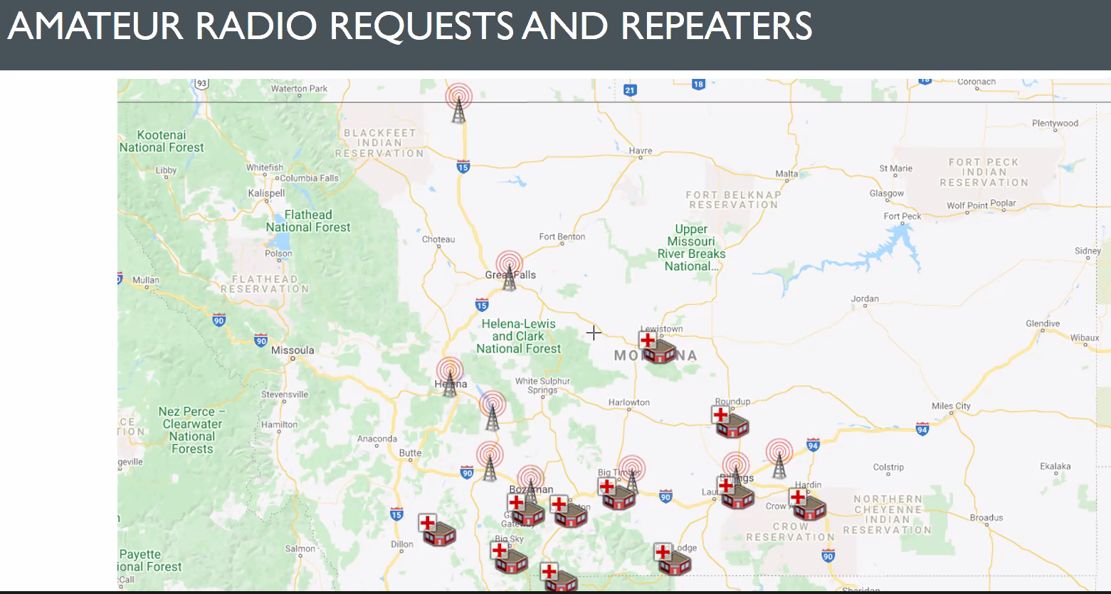
The Eastern Region is proceeding with the same project.
- Charlie motioned to approve the Radio Project, as stated
- Birgen asked for any other discussion and there wasn’t any
- The motion was seconded by Greg
- Approved unanimously

New Business
SRHCC Hazard Vulnerability Analysis (HVA)
Casey presented the Top 30 hazards from the updated HVA which was completed during an all-coordinator meeting this past February 2021
Discussion:
Birgen commented the similarity between Infectious Disease, Epidemic, and Pandemic; all 3 occupying the top 3 hazards. Jason mentioned that it is common for entities to primarily plan for the top 3-5 hazards. Earthquake and Seasonal Influenza are typically higher. Bozeman activated Incident Command 3 times last year due to fires
Casey has planned for work and education for next year based on the top risks. We should combine the similar entries. Flu, Infectious Disease, Epidemic, Pandemic can all be Infectious Disease.
Questions arose as to how we keep track of events so that next years’ is more accurately reflecting the hazards. If facilities used eICS for their own hazards it would automatically feed into the regional view
Casey asked for a workgroup to improve the HVA process. There weren’t any volunteers. Casey will revise the HVA to reflect the suggestions
SRHCC Capability Assessment Tool (CAT) and Workplan
Casey presented the results of the CAT which was completed during an all-coordinator meeting this past February 2021
Please see the document sent to each member prior to the meeting. Casey created an Excel document where she can log work progress on each task. This document will be used to establish next year’s workplan
SRHCC Draft Budget for FY21-22
Casey presented the projected expenses for next fiscal year, beginning July 1, 2021, which looks to be over-budget at $84,252
Peach highlight = historical events
Green highlight = gaps identified in workplan
Blue highlight = Virtual offerings, likely no expense
Gray highlight = items that will be “nice to have” but probably not enough funds
The National Healthcare Coalition Conference is scheduled for Orlando, Florida for early December will likely need to have increased funds allocated due to higher costs
Colin mentioned that many of the projected trainings could likely be brought in as virtual events to reduce the costs
Cindee reminded everyone that the final budget is due sometime in August
SRHCC Highly Infectious Disease (HID) Annex
Casey presented the final version of the draft HID Annex which was completed during an all-coordinator meeting this past February 2021. The document was sent out prior to the meeting for the Committee to review
Cindee overviewed that this is a refined document that had been in draft form prior to COVID-19. Staff took the recommendations from ASPR to improve the document’s benefit to the region
- Having heard no concerns, Bill motioned to approve the draft
- The motion was seconded by Charlie
- The motion was approved unanimously
Montana RHCC Brochure
Casey presented the final version of the marketing brochure describing the Regional Healthcare Coalitions which was completed during an all-coordinator meeting this past February 2021

Coordinator Update
Casey reviewed the recent projects that staff been addressing
- Completed COVID Mini-Grant Disbursements and PAPR purchase
- Amateur Radio Outreach and Discussions
- Completed HVA on behalf of Coalition
- Completed CAT on behalf of Coalition
- Developed 2021-2022 Work Plan
- Developed 2021-2022 Draft Budget
- Edited and Updated HID Annex
- Completed Coalition Brochure
- Weekly Newsletter Publication
- Continued outreach to hospitals on reporting compliance
- Outreach to hospitals on supply and staffing shortages
- Developed Draft Resource Assessment
- Completed BDLS Course
- Completed Principles of Emergency Management Course
- Participated in Preparedness Summit

Upcoming Training & Education
Jake briefed on an upcoming education opportunity from the Rural Domestic Preparedness Consortium (RDCP) for MGT 433, Isolation and Quarantine for Rural Communities.
July 13-14
Virtual for 4 hours each day
See the weekly newsletter for registration instructions
Closing
Roundtable
Charlie – Need to discuss with Cindee and Don how to roll out funds for the Amateur Radio Project.
Scott – There is a reduction in need for COVID19 plasma
Jason – More Carbon County walk-in vaccination clinics since large event participation has decreased. Finalizing a PPE Training course for a Coalition training event this coming Spring
Greg – A decrease in vaccination clinics. 3 more large events are scheduled. The goal is to reduce the response in mid-June
Charlie – Nothing to add
Birgen – Bozeman has been strong and steady in vaccinations. She thinks they will reduce opportunities in May. There have been a lot of no-shows. They want to get back to normal over the Summer. There has been a spike of 20-40 year-olds in Gallatin County with new variants. Education continues and vigilance with media assistance continues. They are planning for wildfires and burns as well as an airport exercise with the County in May
Bill – Same as others. The public vaccination clinics are reduced now and only small events planned. Especially for the Senior class from the high school since there a smaller turnout. Very satisfying experience in collaborating with Tribe and IHS.
Paula – Same as Bill. The LTC following CMS guidelines for visitation will be loosening regulations for residents who are safe. Vaccinations went well.
Kyrsten – WRHCC has some COVID19 funding to assist any region using nursing students who travel to the vaccination clinics. Let Kyrsten or Casey know. The WRHCC is providing eMisters to their LTCF and EMS. Pediatric resources from last year’s Pediatric Surge Table-Top Exercises (TTX) for FQHC and EMS
Kitty – CRHCC completed surveys for the spending plan for both budgets; PAPRs and Pediatric supply gaps. The opportunity for site Visits is optimistic for this Summer as well as delivering equipment purchases
Robbie – ERHCC is also providing Pediatric supplies to clinics and EMS and PAPRs for the hospitals. They are also in the same progress for their radio project as the SRHCC
Cindee – Has been collaborating with Don and Colin on any unmet deliverables for the current grant year. HID Annex TTX AAR/IP, Burn Annex development, Coalition Surge Tests, Supply Chain integrity, Continuity of Operations (COOP), and NIMS assistance are being researched. HPP and RHCC PPE Caches are being finalized and a list of items will be shared. The new grant guidance is our for next fiscal year
Don – The upcoming ASPR grant is now available, likely reducing your funds a small amount. Have been coordinating with Cindee and Colin in reviewing the current grant year for unmet deliverables. ESF8 Advisory Council is being restarted soon. We continue to review Resource shortage reports to see where we can provide assistance
Kevin – Hopeful that operations will be returned to normal come July 1. The PHEP side will begin inspections by CDC in the near future. Summer Institute, week of July 19 in Missoula. Intro to PIO being finalized for the afternoon of July 19 and on July 20 an all-day training session on the Volunteer Registry.
Jake – The MGT433 Isolation & Quarantine class for July 13-14
No other comments
Public Comment
No public comment
Next Meeting
Next meeting will take place:
Regular meeting on August 10th beginning at 10:00 am in perhaps Big Timber to discuss remaining funds for the COVID-19 grant and the HPP grant. Additionally, we need to discuss CAT results and thereby the new year’s Workplan and draft budget presentation, HVA update, HID Plan Annex
Casey will research possible location for the next meeting
Adjourn
- Motion to adjourn made by Bill
- Seconded by Scott
- All approve unanimously
Jason thanked the HPP/HCC team for their hard work

