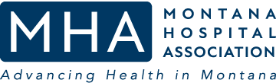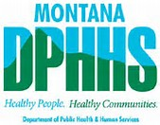

Central RHCC Radiation MCI 2023
Table Top Exercise

After Action Report/Improvement Plan
January 23, 2023

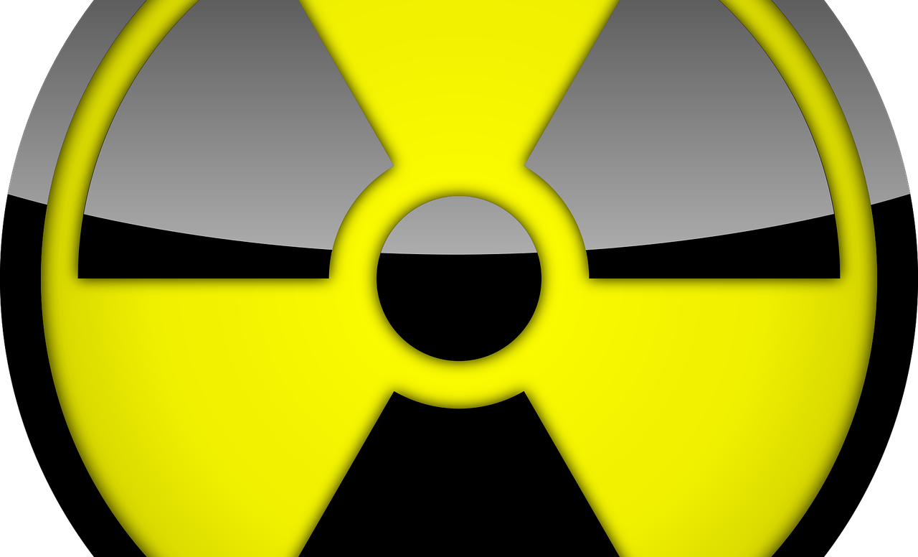
This After Action Report and Improvement Plan is based on national guidance including the National Preparedness Goal, Healthcare Capabilities and related frameworks. It captures information required by federal and state agencies for reporting, trend analysis and improvement planning.

Prepared by:

THIS PAGE INTENTIONALLY BLANK

Introduction
The Central RHCC Radiation MCI 2023 Table Top Exercises were sponsored and hosted by the Regional Healthcare Coalitions (RHCC), with guidance from the Montana Hospital Association (MHA and Montana Department of Health & Human Services (DPHHS). The series of exercises were developed, presented and moderated by Spartan Consulting. The exercises were developed to test participating agencies Healthcare & Medical Response Coordination, Medical Surge, and Foundation for Healthcare & Medical Readiness capabilities in response to a radiation mass casualty incident in their community. The exercise was developed by Spartan Consulting with input, advice, and assistance from MHA and DPHHS and followed the guidance set forth in the Federal Emergency Management Agency (FEMA) Homeland Security Exercise and Evaluation Program (HSEEP).
The ASPR Healthcare Preparedness & Response Capabilities (Nov 2016), CDC’s Public Health Preparedness & Response Capabilities: National Standards for State, Local, Tribal and Territorial Public Health Planning (Jan 2019) and the Montana Regional HealthCare Coalition Radiation Suge Annexes (2022) were used to develop exercise materials and guide evaluation. This report is based on the formats suggested by the HSEEP, Montana Disaster & Emergency Services (DES), and the Montana Department of Public Health and Human Services (DPHHS) for exercise AARs.
The purpose of this report is to analyze exercise results, identify strengths to be maintained and built upon, identify potential areas for further improvement, and support development of corrective actions. The suggested actions in this report should be viewed as recommendations only. In some cases, participants may identify alternative solutions that are more effective or efficient. Each agency should review the recommendations and complete actions in alignment with internal strategies, current program objectives, local, state, and national goals and related frameworks and guidance.

Handling Instructions
The information gathered in this AAR-IP is For Official Use Only. Reproduction of this document, in whole or in part, without prior approval from the Regional Healthcare Coalitions (RHCC) is prohibited.
For more information, please consult the following points of contact (POCs):
Montana Hospital Association  Cindee McKee, Healthcare Preparedness Coord.  2625 Winne Ave.  Helena, MT 59601  (406) 457-8027  Cindee.mckee@mtha.org | Contract Support – Spartan Consulting  Brett Lloyd, BSED, MEP, CHEC, CPM  5848 Green Meadow Dr.  Helena, MT 59602  (406) 431-9386  brett@spartanmt.com

Contents
Introduction ii
Handling Instructions ii
Exercise Overview 4
Exercise Name 4
Exercise Dates 4
Scope 4
Mission Area(s) 4
Core Capabilities 4
Objectives 4
Threat/Hazard 4
Scenario 4
Sponsor(s) 4
Participating Organizations 4
Exercise Summary 5
Exercise Purpose & Design: 5
Exercise Summary 5
Module 1: Activation & Initial Response 7
Key Issues 8
Discussion Questions 8
Module 1: Analysis 8
Module 2: Medical Surge 10
Key Issues 11
Discussion Questions 11
Module 2: Analysis 11
Module 3: Recovery 14
Key Issues 14
Discussion Questions 14
Module 3: Analysis 15
Conclusion 17
Appendix A: Acronym List A-1
Appendix B: Exercise Participants B-1
Appendix C: Improvement Plan C-1

Exercise Overview
Exercise Name | Central RHCC Radiation MCI 2023 Table Top Exercise
Exercise Dates | January 23, 2023
Scope | The Central RHCC Radiation MCI 2023 Table Top exercise was a web-based, moderated exercise planned for 4 hours for the Central Regional Healthcare Coalition. The exercise emphasized the role of the local hospital and supporting local agencies as well as regional coordination in response to a radiation mass casualty incident.
Mission Area(s) | Response, Recovery
Core Capabilities | Healthcare & Medical Response Coordination, Medical Surge, Foundation for Healthcare & Medical Readiness,
Objectives | Objective 1: Discuss and assess the assumptions and assigned responsibilities in the Regional Radiation Incident Annex and the capacity of local and regional partners to meet expected roles and capabilities.  Objective 2: Discuss and assess the ability of the local Healthcare system and other participants to appropriately manage contaminated and/or exposed patients.  Objective 3: Discuss and identify potential gaps in local and regional planning, training, resources, or capabilities.
Threat/Hazard | Radiation Mass Casualty Incident
Scenario | A science fair project at the local school creates a surge of radiation contaminated and exposed patients as well as worried well.
Sponsor(s) | Regional Healthcare Coalitions (RHCC), Montana Hospital Association (MHA), and MTDPHHS
Participating Organizations | See Appendix B

Exercise Summary

Exercise Purpose & Design:
The Central RHCC Radiation MCI 2023 Tabletop Exercise was developed to provide participants with an opportunity to discuss and evaluate current concepts, plans, and capabilities for response to a radiation mass casualty incident in their community. The exercise was developed by Spartan Consulting and followed the guidance set forth in numerous federal documents as well the RHCC Radiation Annexes.

Exercise Summary
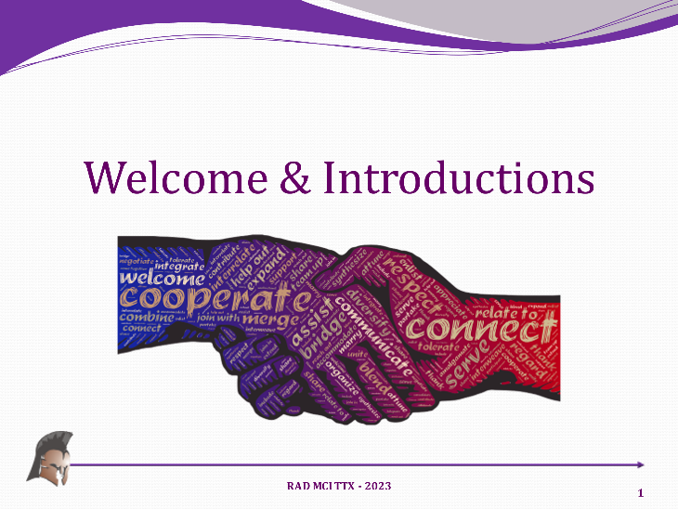
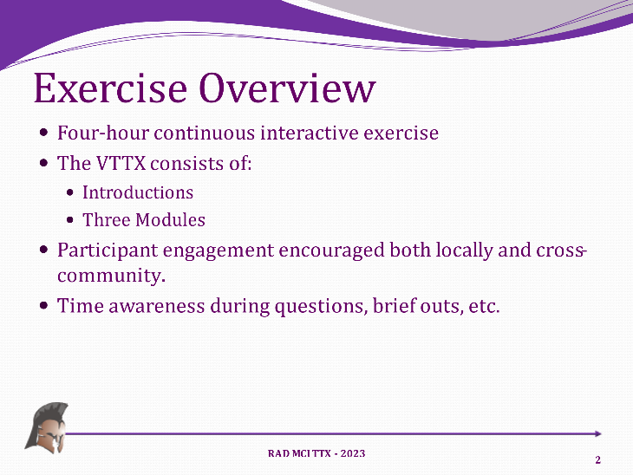
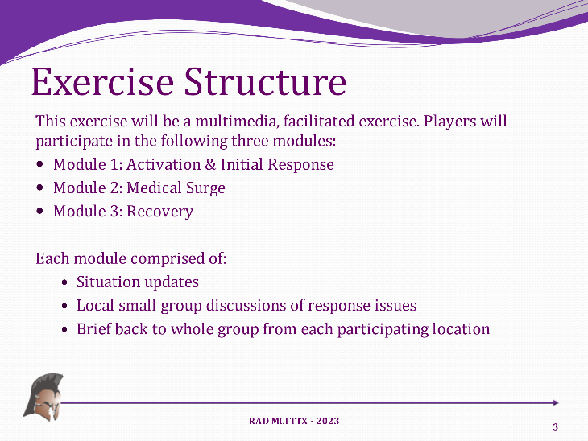
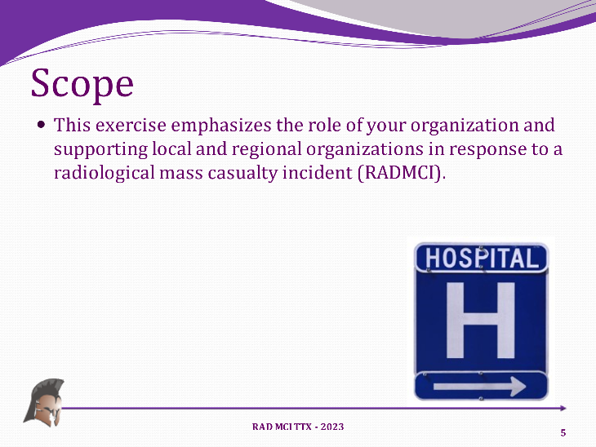
The exercise was scheduled for 4 hours on January 23rd. The exercise used the same scenario and discussion questions as previously and began with an overview presentation on tabletop exercises and the agenda. The exercise scenario was presented to participants and discussion was guided by the Moderator using the following slides:

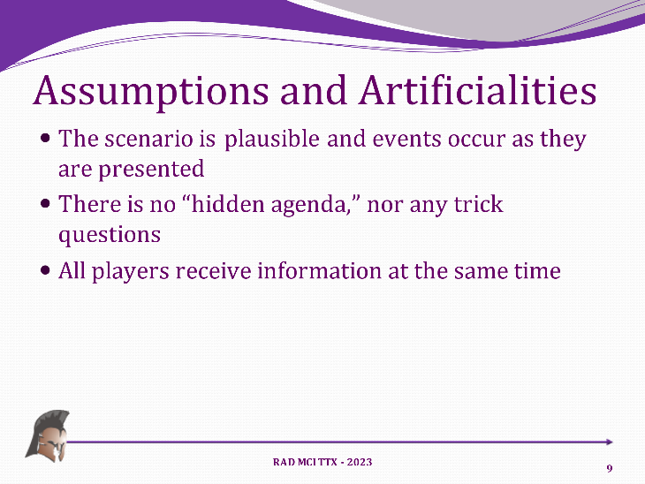
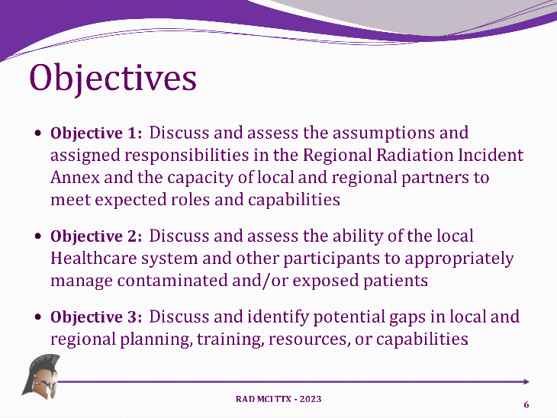
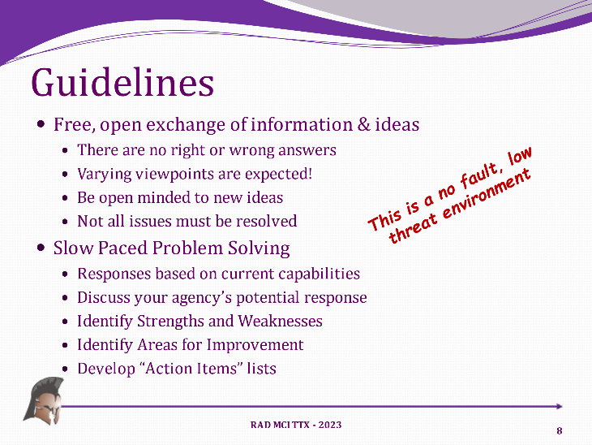
Once all the exercise groundwork was laid, the moderator moved on to Module 1 and the first set of discussion topics.

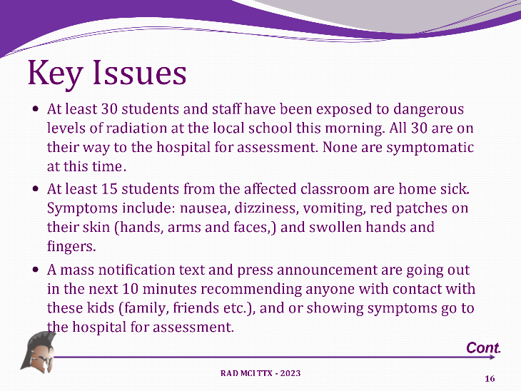
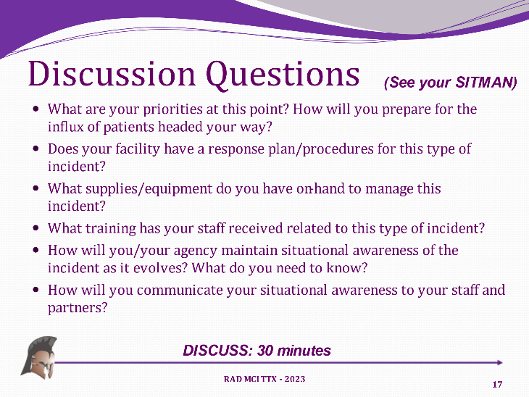
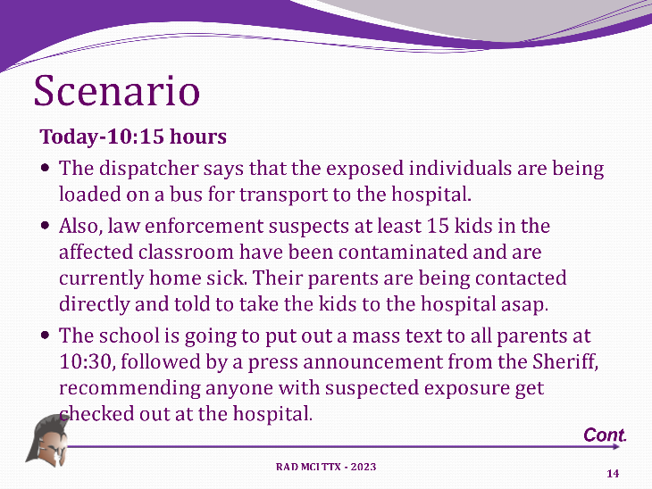
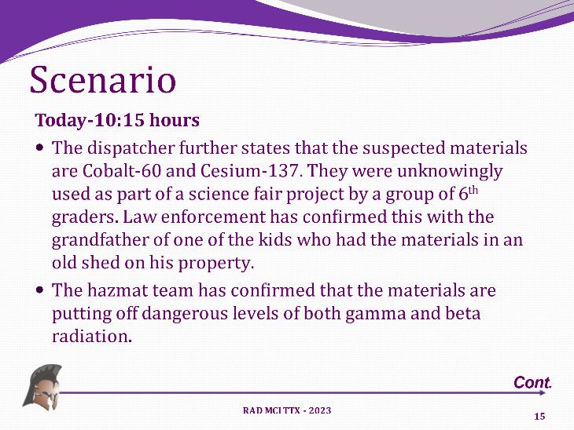
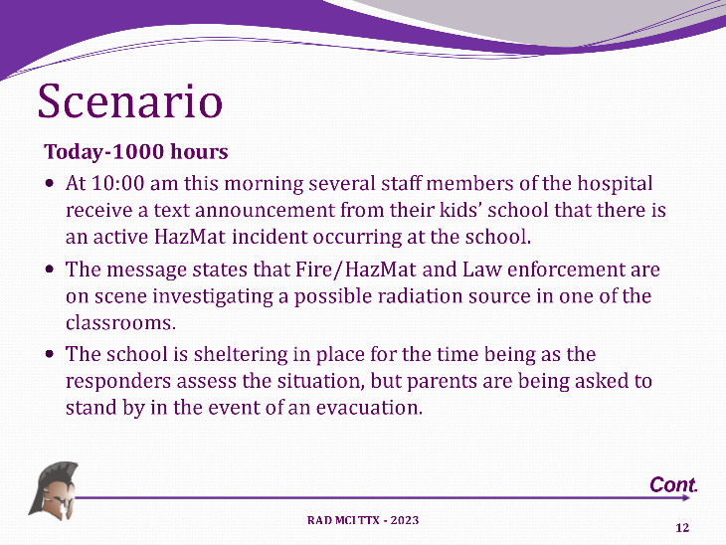
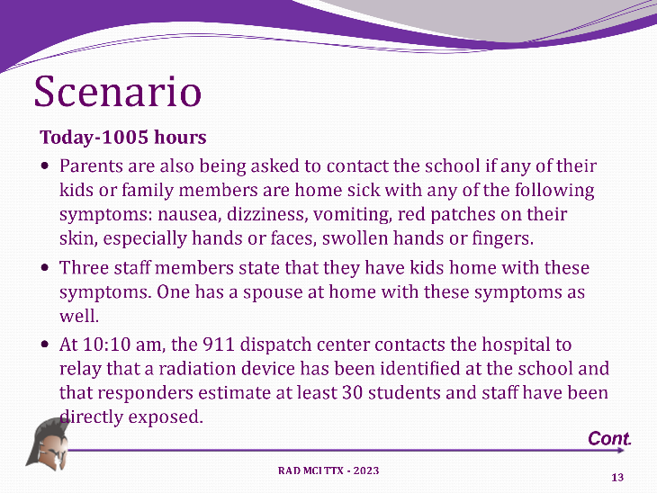
Module 1: Activation & Initial Response

At this point, the exercise Moderator referred the participants to the following key issues and discussion questions:

Key Issues
- HazMat incident occurring at the school.
- Fire/HazMat and Law enforcement are on scene investigating a possible radiation source in one of the classrooms.
- The school is sheltering in place.

Discussion Questions
- What are your priorities at this point? How will you prepare for the influx of patients headed your way?
  - Do these patients need to be decontaminated? What are your decon capabilities?
- Does your facility have a response plan/procedures for this type of incident?
  - What type of “contamination control” measures do you need to take to avoid contaminating the hospital, environment, staff/personnel?
- What supplies/equipment do you have on-hand to manage this incident?
  - What types of PPE does your staff need? Do you have it? Where (else) can you get it?
  - Do you have equipment to test for Radiation? Who (else) does? How do you request it?
- What training has your staff received related to this type of incident?
- How will you/your agency maintain situational awareness of the incident as it evolves? What do you need to know?
- How will you communicate your situational awareness to your staff and partners?

After the allotted time was up, the groups reported back a summary of their discussions.

Module 1: Analysis

Strengths
The following strengths related to this module were observed during the exercise:
Strength 1: Surge Plans – All of the patient care participants have surge plans and several of the participating facilities have hazmat response components that address radiological patients .
Strength 2: Equipment – Many of the critical access hospitals have PPE and decontamination equipment and supplies. A few even have radiological detection equipment and staff that knows how to use it .
Strength 3: HazMat Teams – Each of the Regions has a State HazMat Response team that can be contacted for technical assistance. The Central Region also has the 83rd Civil Support Team. These teams bring a significant capability for agent identification as well as technical guidance on response and protective actions. All hospital plans should have the process for getting assistance from these teams outlined prominently .

Areas for Improvement
The following areas for improvement may help to achieve an even greater capability level:
Area for Improvement 1: HazMat Response Plans
Analysis: Some of the facilities do not have adequate hazmat response plans or ones that adequately address radiological response. Few actually did a threat assessment based on the situation and the agents identified to them to decide if decontamination was needed or even worthwhile at this point. They just assumed that decon was needed. This is likely more of a training issue than a planning one, but if their plans do not address threat assessment etc., they should .
Recommendations/Corrective Actions:
- Review current hospital plans to ensure that they address threat assessment, agent identification and researching appropriate response measures based on the threat to the hospital, staff and patients.
- Provide training to staff on agent identification and research and how to make protective actions decisions.
- Procure or develop “checklists” or other helpful decision-making tools for identifying and implementing protective actions during a hazmat incident.
Area for Improvement 2: HazMat/Decon Training
Analysis: While most of the facilities and participants have some rudimentary understanding of “hazardous materials” most of them actually lack the technical expertise to do appropriate hazmat risk assessment and protective actions planning without doing research or seeking assistance. This takes time that patients, and the staff, may not have. Additionally, most of the hospitals that have decon teams have not been able to train or exercise for several years due to Covid and other factors. HazMat knowledge and response actions are perishable skills that can deteriorate quickly if not tested and refreshed regularly. In short, most of the participants really did not know what to do given the situation and reacted “generically” in that they planned for wet decon and full PPE etc. While defaulting on the side of caution is usually the best action, it can also cause people to take unnecessary or even determinantal actions as well. In this case, choosing to wet decon people that likely had no surface contamination took a significant amount of time and resources that could have been spent on patient care. It also introduced the possibility of further spreading any actual contamination and creating a worse situation at the hospital. Radioactive material behaves very differently than chemical materials in the environment and when it comes into contact with water. Having more in depth knowledge of the materials involved, or knowing where to get it, as well as having a quick reference tool or checklist for certain actions, like decon, could have saved time and effort and helped the players make better decisions .
Recommendations/Corrective Actions:
- Identify staff that could/would be involved in hazmat response and determine minimum levels of training and/or certification for each. Make sure to include things like cleanup, waste management, follow-up and refresher training requirements as well.
- Conduct HazMat awareness and operations level training for staff that could/would be involved in response.
- Conduct both tabletop and functional exercises to discuss and practice key response activities like threat assessment, protective action planning, decon, contamination control, cleanup etc.

Module 2: Medical Surge
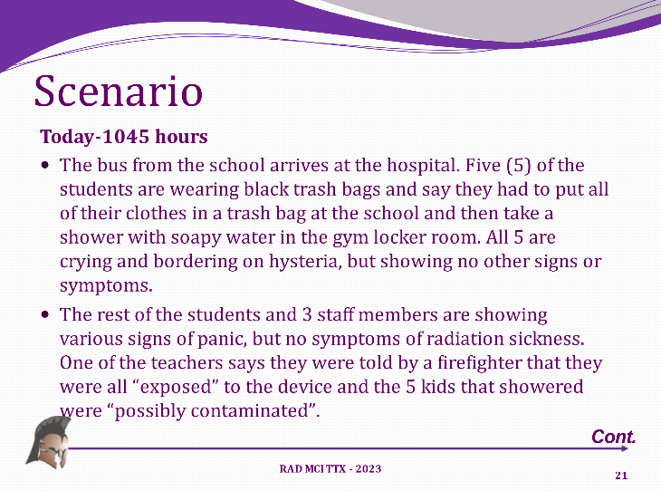
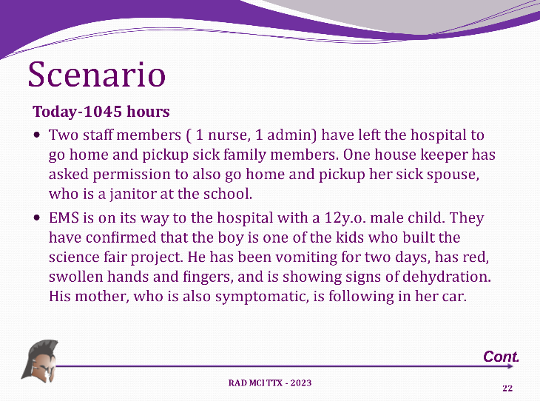
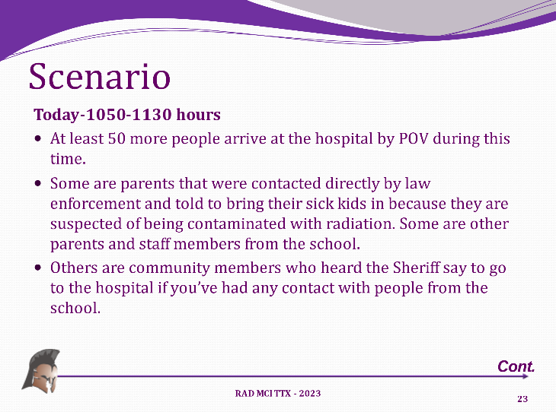
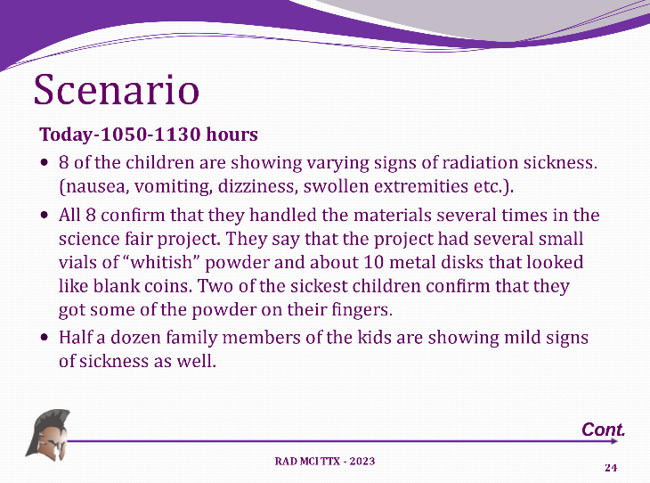
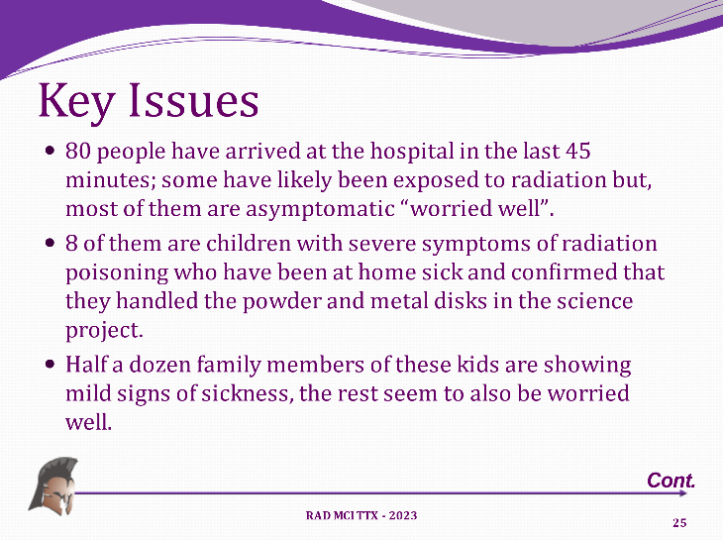
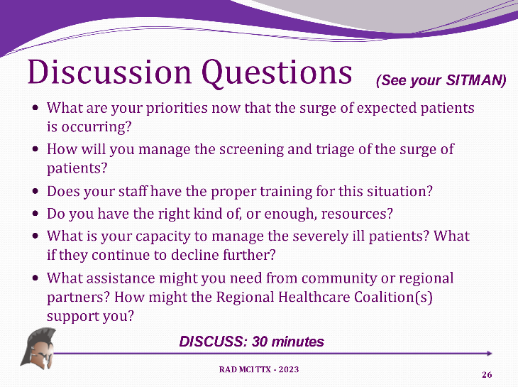
The Moderator then continued the exercise with Module 2: “Medical Surge” and presented the following scenario updates:

The groups then addressed the following key issues and discussion questions:

Key Issues
- Dozens of people arriving at hospital.
- Some are children with severe symptoms of radiation poisoning.

Discussion Questions
- What are your priorities now that the surge of expected patients is occurring?
  - Contamination control, exposure of staff and facility
- How will you manage the screening and triage of the surge of patients?
  - Do you have radiation monitors? Guides for treating radiated patients? MMG’s
- Does your staff have the proper training for this situation?
  - Can they conduct screening, PPE use, and decon?
- Do you have the right kind of, or enough, resources?
  - Radiation monitors, PPE, Decon,
- What is your capacity to manage the severely ill patients? What if they continue to decline further?
- What assistance might you need from community or regional partners? How might the Regional Healthcare Coalition(s) support you?

Module 2: Analysis

Strengths
The following strengths related to this module were observed during the exercise:
Strength 4: Key Staff – The hospitals that had radiological (imaging) staff recognized quickly that these people needed to be at the ED with their testing equipment to analyze contamination amounts on incoming patients. As mentioned prior, some of the hospitals do have dosimeters and other individual equipment, but it is likely they could use more and would need more in this type of incident to get true situational awareness .
Strength 5: Support Facilities – It was recognized early that these patients would need specific types of treatment and care. Several of the players understood what that would entail and where the patients may need to be transferred to do so. This would be critical for the smaller, critical access hospitals that might not have the capacity to do much more than stabilize and transfer seriously ill patients. Regional Coordination from the RHCC could assist in this way by helping coordinate those placements and alleviating the workload of the small hospital that is dealing with the surge .

Areas for Improvement
The following areas for improvement may help to achieve an even greater capability level:
Area for Improvement 3: Screening & Triage of Contaminated Patients
Analysis: It was clear from the discussions that many of the facilities/players were not exactly sure what this activity should look like. Most argued that it would need to take place outside, be done my ED staff and that those staff would need to be in full PPE. While this is all true, the assumption had already been made that all of the incoming patients would be routed through wet decon, which was not the best solution. Further screening would have identified who was likely contaminated and who was not and could have sped up the process considerably. Again, this is seen as more of a training and experience issue and can and should be corrected through more training and exercises. However, there is an argument to be made for updating or revising plans and procedures to make this process more standardized and repeatable regardless of experience level., (e.g. checklists, decision making algorithms, etc.) .
Recommendations/Corrective Actions:
- Ensure that hospital response plans have patient screening and decision-making tools for hazmat incidents to help them determine priorities appropriately. Triage tools like START, SALT and TRAIN will not be applicable to this situation, so others will need to be found or developed .
- Conduct training that includes patient screening and triage best practices during a hazmat response.
- Ensure that future hazmat exercises include patient screening and triage activities and objectives.
Area for Improvement 4: Public Information to Manage Surge
Analysis: While it was not emphasized in the discussion questions, there were comments in the situation update that indicated a great deal of the surge of worried well was due to law enforcement directing people to the hospital. Few if any of the players addressed this as a problem, perhaps because we had more patient care people than PIOs. However, the impacts to the hospital were recognized as they were now dealing with over 80 patients, many of whom really should not have come to the hospital unless they were symptomatic. The “surge” was mainly due to nonexperts directing anyone and everyone that might have been exposed to seek medical care, which is bad advice. Radiological materials are different than chemical ones and there is no “one-size-fits-all” approach. The hospital should have had their PIO or CEO contact the law enforcement leaders making these comments and crafted different messaging to alleviate the surge of worried well that ultimately were getting in the way of actual victims .
Recommendations/Corrective Actions:
- Ensure that a PIO or designated spokesperson is aware of the potential impacts of a radiological incident, (e.g. surge of worried well, panic, etc), and craft messaging or be prepared to coordinate with other responders to manage that. One strategy is to send worried well or “possibly exposed” people to another screening location and only have people who are actually symptomatic report to the hospital.
- Ensure that public messaging and joint information systems are components of future training and exercises. Focus on “proactive” rather than “reactive” messaging to help manage surge, panic and stigma. Remember that the average person knows very little about CBRNE or hazmat and will likely have a great deal of anxiety, whether they are symptomatic or not, if they think they’ve been affected.
- Provide “Crisis Risk Communications” Training to community an agency spokespersons and PIOs to help them understand the difference between public education and public information as well as “risk communications”.

Area for Improvement 5: Equipment Caches
Analysis: While many of the hospitals do have a few sets of PPE (6-12 max) and some had radiation detection monitors, it was quickly realized that they would start running out of things very quickly. Traditional PPE (gloves, masks, gowns, etc.) would not be adequate for this type of incident, nor for most CBRNE incidents so unless it could be found and delivered rapidly, a PPE shortage could have significant staff safety and patient care implications. .
Recommendations/Corrective Actions:
- Research the possibility of the RHCC working with DPHHS and DES to develop or augment existing equipment caches (e.g. SNS) to include things needed for a radiological incident response.
- Ensure that hospital plans have procedures for requesting and receiving such a cache.
- Provide training and exercises that include requesting, receiving and utilizing cached equipment from a “state warehouse” or cache location.

Module 3: Recovery
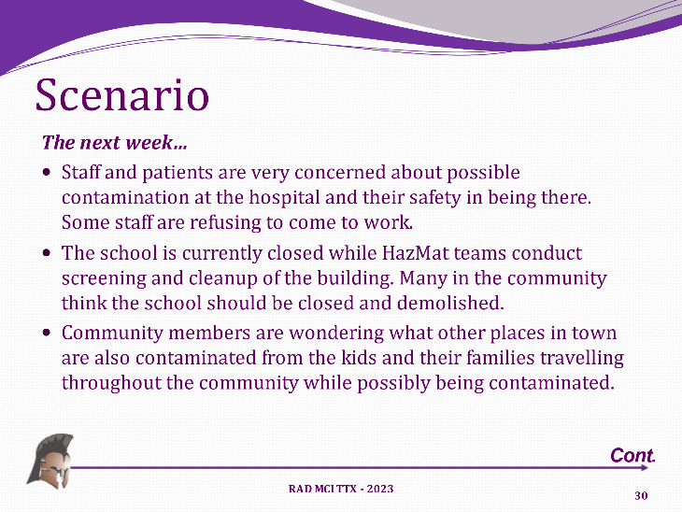
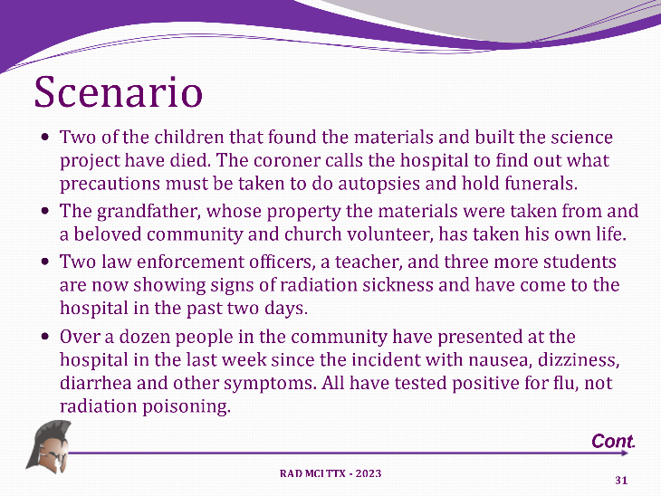
After some time for brief back discussion, the Moderator then moved into Module 3 “Recovery” by introducing the following slides.

The groups then discussed the key issues and discussion questions:

Key Issues
- Contamination/cleanup challenges at the hospital and in the community.
- Ongoing monitoring of anyone potentially exposed (school staff, kids, responders and hospital staff)
- Potential staffing issues
- Fatalities management
- Mental health issues and treatment
- Public Information and education
- Long term treatment of victims.

Discussion Questions
- What type of testing and cleanup capacity does your agency have for dealing with any environmental contamination at your facility?
- How will you monitor and follow-up with any potential exposed staff and patients?
- How will closing the school and staff refusal to come to work impact your facility?
- What special considerations must be made for fatality management?
- What mental health resources might you need? What do you have available?
- How will you manage public information and education to minimize the continued flow of worried well and impacts to the hospital and community?
- What long term care considerations will be needed for the victims of this incident? What do you have available?

Module 3: Analysis

Strengths
The following strengths related to this module were observed during the exercise:
Strength 6: Covid Response – Covid Response as taught the hospitals and staff a lot of relevant lessons such as dealing with access control, visitors, patient surge, staff challenges, contamination control, public messaging and more. Many of these lessons would be relevant in an incident of this type .
Strength 7: CISM – All of the players understood the need for mental and behavioral health strategies following and incident of this type. Furthermore, they have resources readily available .

Areas for Improvement
The following areas for improvement may help to achieve an even greater capability level:
Area for Improvement 6: Cleanup and Contamination Monitoring
Analysis: Radioactive materials cleanup and monitoring is a very complex, and costly, undertaking. In this scenario, there could be significant contamination at the school, at the hospital, and at several homes and businesses throughout the community. The players really did not have a clear understanding of these facts nor were they really aware of how it might impact their hospital and community. Recovery could and likely would be the hardest and most complex part of the incident. And since this was not a “terrorist attack” it is likely the federal government would have limited involvement outside of the normal “declaration” process. The hospital needs to work with community leaders to be part of any emergency or disaster declarations and to understand what types of specialized resources (i.e. “contracted”) will be needed to do a proper cleanup and conduct ongoing testing and monitoring and whether their costs would be covered or reimbursed. They also need to check their insurance to see if these types of services and costs would be covered .
Recommendations/Corrective Actions:
- Ensure that response plans address the complexities of hazmat incident testing, cleanup and monitoring.
- Provide training to hospital leadership on how to work with local DES and elected officials to be part of an emergency or disaster declaration.
- Encourage hospitals to check with their insurance providers on whether hazmat cleanup costs would be covered and if not, pursue other options, such as contingency funds at the state level, rider policies in high risk areas etc.
Area for Improvement 7: Long Term Patient Care
Analysis: Providing long term support for the most seriously injured victims is beyond the capability of most small hospitals. Care management plans will need to be developed and many of the sickest patients will need care and resources outside the community and perhaps outside Montana .
Recommendations/Corrective Actions:
- Ensure that local and regional plans identify facilities that could provide long term care in this type of incident as well as referral and transfer procedures.

Area for Improvement 8: Public Information & Messaging
Analysis: This topic was discussed earlier with regard to managing surge, however with recovery it will also be crucial. As people’s fears, real or imagined, lead them to drastic solutions, it will be the hospital’s challenge to reassure the community that it is safe to come there, that your facility has been tested, cleaned and is being monitored to protect them. You will have to build/rebuild the public’s trust and your image, especially if here have been fatalities and that will take more than just providing situation updates, it will take some marketing expertise as well .
Recommendations/Corrective Actions:
- Ensure that recovery plan address public messaging and reputation recovery as well.
- Ensure participation on local LEPC/TERC to stay informed of local hazards and make contacts with local responders and hazmat experts to support hospital efforts.
- Include “recovery messaging” activities in future trainings and exercises.

Conclusion
The Central RHCC Radiation MCI 2023 Tabletop Exercise was developed to provide participants with an opportunity to discuss and evaluate current concepts, plans, and capabilities for response to a radiation mass casualty incident in their community.
Participants completed all planned exercise objectives, and were able to identify plans, policies, and procedures that require further development, updating or changing.
Aligning exercise objectives and core capabilities provides a consistent taxonomy for evaluation that transcends individual exercises to support preparedness reporting and trend analysis. Table 1 below includes the exercise objectives, aligned core capabilities, and performance ratings for each core capability as observed during the exercise and determined by the evaluation team.
Objective | Core Capability(s) | Performance Rating
- Discuss and assess the assumptions and assigned responsibilities in the Regional Radiation Incident Annex and the capacity of local and regional partners to meet expected roles and capabilities. . | Healthcare & Medical Response Coordination | 2 - Performed with Some Challenges
- Discuss and assess the ability of the local Healthcare system and other participants to appropriately manage contaminated and/or exposed patients. | Medical Surge | 2 - Performed with Some Challenges
- Discuss and identify potential gaps in local and regional planning, training, resources, or capabilities. | Foundation for Healthcare & Medical Readiness | 2 - Performed with Some Challenges
Ratings Definitions:
3 - Performed without Challenges: The targets and critical tasks associated with the core capability were completed in a manner that achieved the objective(s) and did not negatively impact the performance of other activities. Performance of this activity did not contribute to additional health and/or safety risks for the public or for emergency workers, and it was conducted in accordance with applicable plans, policies, procedures, regulations, and laws.
2 – Performed with Some Challenges: The targets and critical tasks associated with the core capability were completed in a manner that achieved the objective(s) and did not negatively impact the performance of other activities. Performance of this activity did not contribute to additional health and/or safety risks for the public or for emergency workers, and it was conducted in accordance with applicable plans, policies, procedures, regulations, and laws. However, opportunities to enhance effectiveness and/or efficiency were identified.
1 – Performed with Major Challenges: The targets and critical tasks associated with the core capability were completed in a manner that achieved the objective(s), but some or all of the following were observed: demonstrated performance had a negative impact on the performance of other activities; contributed to additional health and/or safety risks for the public or for emergency workers; and/or was not conducted in accordance with applicable plans, policies, procedures, regulations, and laws.
0 - Unable to be Performed: The targets and critical tasks associated with the core capability were not performed in a manner that achieved the objective(s).

Table 1. Summary of Core Capability Performance
This exercise revealed many of the challenges facing the participants in responding to a radiological mass casualty incident. The exercise scenario tested plans and procedures regarding response and coordination, and the participants demonstrated that their commitment and intent to support the response community and cooperate with one another is impressive. This provides a strong foundation for future coordination, planning, and overall emergency preparedness for their communities.
During the post-exercise “hotwash”, participants were able to identify several recommendations for improvement, including
- Further development and revision of plans and procedures to more clearly define roles and responsibilities of key departments and personnel,
- Continued organization of supplies and resources; and,
- Continue to conduct regular drills and exercises to validate plans and training.
Participants can use the results of this exercise to further refine plans, procedures and future capabilities-based training and exercises addressing critical components of the overall response.
All exercise issues and recommendations are outlined in the Improvement Plan (IP) in Appendix C.

Appendix A: Acronym List
Acronym | Meaning
AAR/IP | After Action Report/Improvement Plan
ASPR | (Office of the) Assistant Secretary for Preparedness and Response
CEO | Chief Executive Officer
CISM | Critical Incident Stress Management
DES | Disaster & Emergency Services
DHS | Department of Homeland Security
DPHHS | Department of Public Health & Human Services
ED | Emergency Department
EMS | Emergency Medical Services
EOC | Emergency Operations Center
EOP | Emergency Operations Plan
FEMA | Federal Emergency Management Agency
HCC | Hospital Command Center
HICS | Hospital Incident Command System
HSEEP | Homeland Security Exercise & Evaluation Program
IAP | Incident Action Plan
IC | Incident Commander
ICP | Incident Command Post
ICS | Incident Command System
IMT | Incident Management Team
IP | Improvement Plan
JIC | Joint Information Center
MCI | Mass Casualty Incident
MHA | Montana Hospital Association
NGO | Non-Governmental Organization
NIMS | National Incident Management System
PIO | Public Information Officer
POC | Point Of Contact
RAD | Radiological
RHCC | Regional Healthcare Coalition
SOP | Standard Operating Procedure

Appendix B: Exercise Participants
Participating Agencies and Organizations
Hospitals/Healthcare/Local
St. Peter’s Healthcare
Great Falls Clinic
Great Falls Fire & Emergency Management
Cascade County Public Health
Alluvian Health
State/Federal
Montana Department of Public Health & Human Services
Malmstrom AFB
Private/Non-Profit
Montana Hospital Association
Spartan Consulting

Appendix C: Improvement Plan
This IP has been developed specifically for participants in the Regional Healthcare Coalitions (RHCC) sponsored Central RHCC Radiation MCI 2023 Tabletop exercise conducted on January 23, 2023.
Table C.1 Improvement Plan Matrix
Area For Improvement | Recommendation | Responsible Party | Start Date | Finish Date | Notes
1. HazMat Response Plans | - Ensure facility and agency Emergency Operations Plans have a Radiation Annex. | CRHCC Coordinator | January 23, 2023 | December 31, 2023 | Address during site visits and offer resources when requested
 | - Provide training opportunities and resources to staff on agent identification research and how to make decisions for protective actions | CRHCC Coordinator | January 23, 2023 | December 31, 2023 | Provide HERT/ BDLS / ADLS Training, DOE collaborations, webinars. Resources are in the CRHCC Radiation Annex
2. HazMat/Decon Training | - Include resources for cleanup, waste management, follow-up and refresher training requirements in the CRHCC Radiation Annex as needed. | CRHCC Coordinator | January 23, 2023 | December 31, 2023 | Keep updated and current references in Annex appendix as needed.
 | - Conduct HazMat awareness and operations level training for staff that could/would be involved in response | CRHCC Coordinator | January 23, 2023 | December 31, 2023 | Provide HERT/ BDLS / ADLS Training, DOE collaborations, webinars. Resources are in the CRHCC Radiation Annex
3. Screening & Triage of Contaminated Patients | - Patient screening and decision-making tools for hazmat incidents to help them appropriately determine priorities, will be made available to the CRHCC members as able. Offer training that includes patient screening and triage best practices during a hazmat response. Ensure that future hazmat exercises include patient screening and triage activities and objectives | CRHCC Coordinator | January 23, 2023 | December 31, 2023 | Provide HERT/ BDLS / ADLS Training, DOE collaborations, webinars. Resources are in the CRHCC Radiation Annex
4. Public Information to Manage Surge | - Assist the PIO or designated spokesperson if requested. | CRHCC Coordinator | January 23, 2023 | December 31, 2023 | Provide assistance if requested Ensure that public messaging and joint information systems are components of future training and exercises. Focus on “proactive” rather than “reactive” messaging to help manage surge, panic and stigma.
5. Equipment Caches | - Research the possibility of the RHCC working with DPHHS and DES to develop or augment existing equipment caches (e.g. "state warehouses or SNS) to include things needed for a radiological incident response. | CRHCC Coordinator | January 23, 2023 | December 31, 2023 | RHCC’s work with the DPHHS PHEP SNS Coordinators to access this cache as needed.
6. Cleanup and Contamination Monitoring | - The CRHCC Radiation Annex should provide resources that address the complexities of hazmat incident testing, cleanup and monitoring | CRHCC Coordinator | January 23, 2023 | December 31, 2023 | Resources will be added and updated during the next review of the CRHCC Radiation Annex
 | - Provide training to hospital leadership on how to work with local DES and elected officials to be part of an emergency or disaster declaration | CRHCC Coordinator | January 23, 2023 | December 31, 2023 | Provide HERT/ BDLS / ADLS Training, DOE collaborations, webinars. Resources are in the CRHCC Radiation Annex
8. Public Information & Messaging | - The recovery plan should address public messaging and reputation recovery as needed | CRHCC Coordinator | January 23, 2023 | December 31, 2023 | The potential to offer PIO and or communication courses, trainings and exercises will be considered
 | - HCC's will participate at local LEPC/TERC to stay informed of local hazards and make contacts with local responders and hazmat experts to support hospital efforts as able | CRHCC Coordinator | January 23, 2023 | December 31, 2023 | The potential to offer PIO and or communication courses, trainings and exercises will be considered
 | - Include “recovery messaging” activities in future trainings and exercises | CRHCC Coordinator | January 23, 2023 | December 31, 2023 | The potential to offer PIO and or communication courses, trainings and exercises will be considered

THIS PAGE INTENTIONALLY BLANK

http://dphhs.mt.gov/ | http://www.mtha.org

www.spartanmt.com

Radiation equipment for screening (pancake probes) will be necessary to screen and determine need for and effectiveness of decontamination for both patients, worried well, and workers.

